FINAL PROJECT REPORT
AUTOMATED THREAT DETECTION SYSTEM
Machine Learning Based Network Threat Detection
Submitted by: Shreya
Course: BSc Artificial Intelligence
College: VES College, Chembur
Project: Internship / Final Project
Year: 2026

EXECUTIVE SUMMARY
The Automated Threat Detection System is a machine-learning-based web application developed to identify whether network traffic is normal or potentially suspicious. The system uses network traffic information such as bytes and packets as input features.
A Random Forest Classifier is trained using a network traffic dataset and is used to classify the input as either Normal Activity or Threat Detected. The system includes a Flask backend/API, a web dashboard, SQLite database for storing detection records, input validation, security testing, and cloud deployment using Render.
The project demonstrates the complete workflow of a basic machine-learning security application, starting from dataset preparation and preprocessing and continuing through model training, API integration, dashboard development, testing, and deployment.
The current project uses a small/synthetic dataset, so it should be considered a prototype rather than a production-level threat detection system. Future improvements can include larger real-world datasets, additional network traffic features, stronger authentication, persistent cloud storage, improved model evaluation, and more advanced threat detection techniques.

1. INTRODUCTION
Modern computer networks generate a large amount of traffic every day. This traffic may contain normal communication as well as patterns that could indicate suspicious or potentially harmful activity.
Monitoring large amounts of network traffic manually can be time-consuming and difficult. Automated threat detection can help by analyzing traffic using software and machine-learning techniques and providing a quick classification.
The Automated Threat Detection System developed in this project uses Machine Learning to analyze network traffic and classify it into two categories:
- Normal Activity
- Threat Detected
The main input features used by the current system are:
- Bytes – the amount of network data.
- Packets – the number of network packets.
The system combines a trained machine-learning model with a web application so that users can enter traffic information and receive a detection result.
1.1 What is Network Threat Detection?
Network threat detection is the process of monitoring network activity to identify suspicious or potentially harmful behavior.
A threat detection system can use different techniques such as:
- Rule-based detection
- Statistical analysis
- Machine Learning
- Anomaly detection
In this project, Machine Learning is used to classify network traffic based on the patterns learned from the training dataset.
1.2 Project Overview
The system follows a simple workflow:
Network Traffic → Data Preprocessing → Random Forest Model → Threat Detection → Result
The result is then displayed through the web application. Detection records can also be stored in the SQLite database.

2. PROBLEM STATEMENT
Network traffic is continuously increasing, making manual monitoring difficult.
The major problems identified are:
- Increasing network traffic makes manual monitoring difficult.
- Suspicious traffic needs to be identified quickly.
- Manual analysis requires time and effort.
- Large amounts of traffic can be difficult to analyze continuously.
- There is a need for an automated system that can classify network activity.
- Detection records need to be stored for future review.
Therefore, this project aims to develop a basic automated system that uses Machine Learning to analyze network traffic and provide a quick classification result.

3. PROJECT OBJECTIVES
The main objectives of the project are:
- To develop an automated network threat detection system.
- To use Machine Learning for threat classification.
- To analyze network traffic using bytes and packets.
- To provide quick detection results.
- To provide a simple web-based dashboard.
- To store threat detection records using SQLite.
- To implement input validation.
- To perform system and security testing.
- To provide an API for prediction.
- To deploy the application on a cloud platform.
- To create a foundation that can be improved using larger and more realistic datasets.

4. SCOPE OF THE PROJECT
The project focuses on developing a prototype for automated network traffic classification.
The system accepts network traffic information, processes the input, sends it to a trained Random Forest model, and displays the classification result.
4.1 In-Scope Features
The project includes:
- Network traffic input
- Data preprocessing
- Machine-learning model training
- Random Forest classification
- Flask backend
- Prediction API
- Web dashboard
- SQLite database
- Threat logging
- Input validation
- Security testing
- GitHub repository
- Cloud deployment using Render
4.2 Limitations
The current system has some limitations:
- The dataset used is small/synthetic.
- Only a limited number of network traffic features are used.
- The system provides basic binary classification.
- It does not identify detailed attack categories.
- The prototype is not intended to replace a complete enterprise intrusion detection system.
- More extensive real-world testing is required before production use.

5. TECHNOLOGIES USED
Technology | Purpose
Python | Main programming language
Pandas | Data processing and dataset handling
Scikit-learn | Machine Learning
Random Forest | Threat classification
Flask | Backend and API
SQLite | Storage of detection records
HTML | Dashboard structure
CSS | Dashboard styling
JavaScript | Dashboard interaction
GitHub | Source-code management
Gunicorn | Production server
Render | Cloud deployment
5.1 Python
Python is used as the main programming language because it provides libraries for data processing, Machine Learning, web development, and application development.
5.2 Pandas
Pandas is used to load, process, and prepare the network traffic dataset.
5.3 Scikit-learn
Scikit-learn provides the Machine Learning tools required to train and use the Random Forest classifier.
5.4 Flask
Flask is used to develop the backend and prediction API. It connects the web dashboard with the Machine Learning model.
5.5 SQLite
SQLite is used as a lightweight database for storing detection records.
5.6 HTML, CSS and JavaScript
These technologies are used to create the web dashboard and provide user interaction.
5.7 GitHub
GitHub is used to store and manage the project source code.
5.8 Render
Render is used to deploy the Flask application so that the API can be accessed through the internet.

6. SYSTEM ARCHITECTURE
The system follows a simple processing pipeline.
System Flow
Network Traffic
↓
Data Preprocessing
↓
Random Forest Model
↓
Threat Detection
↙ ↘
Normal Activity Threat Detected
↓
Alert
↓
Feedback Loop
6.1 Architecture Components
1. Network Traffic
The system receives network traffic information such as bytes and packets.
2. Data Preprocessing
The input data is checked and prepared in the format required by the Machine Learning model.
3. Random Forest Model
The trained Random Forest classifier analyzes the input features and generates a prediction.
4. Threat Detection
The prediction is converted into one of two results:
- Normal Activity
- Threat Detected
5. Alert
If the system detects a potential threat, the result can be used to generate an alert.
6. Database
Detection information can be stored in SQLite for future review.
7. Feedback Loop
The feedback loop represents the future process of reviewing detection results and using validated information to improve the system and its training data.

7. SYSTEM DESIGN
7.1 Frontend Design
The frontend is developed using HTML, CSS, and JavaScript.
The dashboard provides:
- Input fields for network traffic values
- A detection button
- Detection result display
- User-friendly interface
The user can enter values such as bytes and packets and submit them for analysis.
7.2 Backend Design
Flask is used as the backend framework.
The backend performs the following tasks:
- Receives the request from the dashboard.
- Validates the input.
- Prepares the data for the model.
- Loads the trained Random Forest model.
- Generates a prediction.
- Returns the result to the dashboard.
- Stores the detection record where configured.
7.3 Database Design
SQLite is used as the database.
The database can store information related to detection requests, such as:
- Input traffic values
- Detection result
- Request information
- Timestamp or related record information
The database provides a way to maintain a history of detection activity.
7.4 API Design
The prediction API provides communication between the frontend and backend.
The general workflow is:
Dashboard
↓
Flask API
↓
Input Validation
↓
Machine Learning Model
↓
Prediction
↓
API Response
↓
Dashboard
This design also makes it possible to test the prediction service independently of the dashboard.

8. DEVELOPMENT AND IMPLEMENTATION
8.1 Dataset Preparation
A small/synthetic network traffic dataset was prepared for the project.
The dataset contains traffic-related values that are used to train the classification model.
The current dataset is mainly intended to demonstrate the Machine Learning workflow. A larger real-world dataset would be required for stronger evaluation.
8.2 Data Preprocessing
The data preprocessing process includes:
- Loading the dataset using Pandas.
- Checking the required columns.
- Checking the data values.
- Preparing the input features.
- Separating the features and target label.
- Preparing the data for model training.
8.3 Model Training
The Random Forest Classifier is trained using the prepared dataset.
The model learns patterns between the network traffic features and their corresponding labels.
After training, the model is saved as a .pkl file.
This allows the application to load the trained model when making predictions without retraining it for every request.
8.4 Flask API Development
The Flask backend loads the trained model and provides an API endpoint for prediction.
When the user submits traffic data:
User Input
↓
Flask API
↓
Validation
↓
Random Forest Model
↓
Prediction
The prediction is then returned to the dashboard.
8.5 Dashboard Development
A web dashboard was developed using HTML, CSS, and JavaScript.
The dashboard allows the user to:
- Enter bytes.
- Enter packets.
- Submit the traffic information.
- View the detection result.
The dashboard communicates with the Flask backend through the API.
8.6 Threat Logging
The system supports storing detection records using SQLite.
Logging is useful because it allows previous detection activity to be reviewed later.
8.7 Deployment
The project source code is maintained using GitHub.
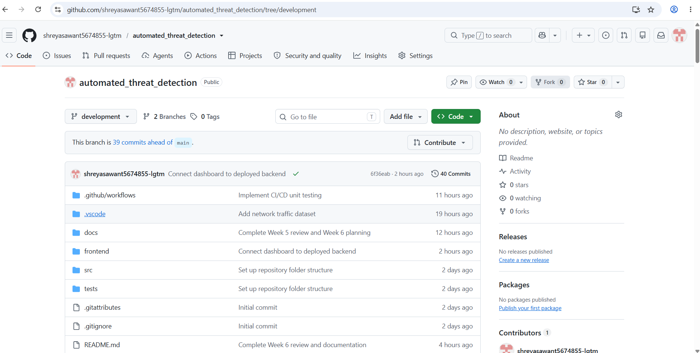
The Flask application can be deployed on Render using a production server such as Gunicorn.
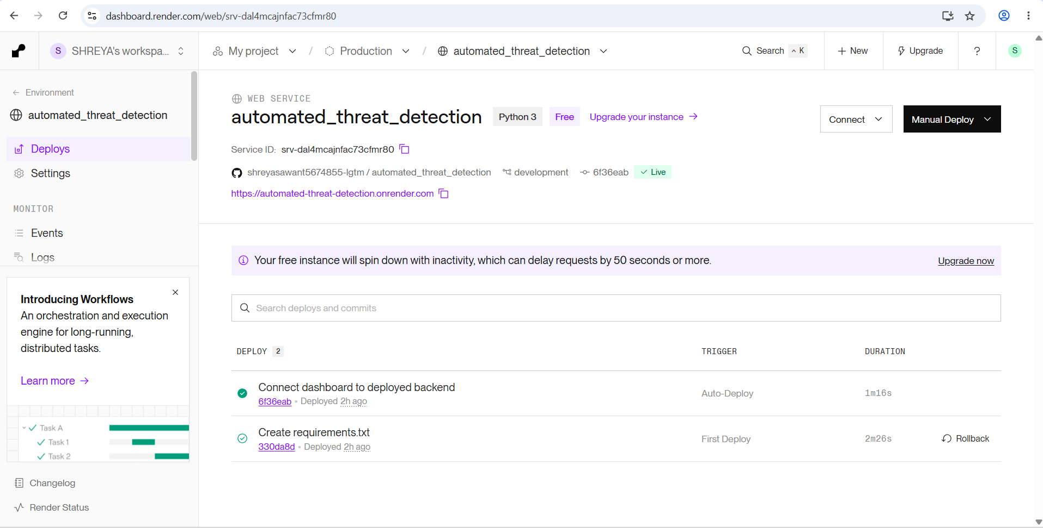
The general deployment flow is:
GitHub Repository
↓
Render
↓
Flask + Gunicorn
↓
Live API

9. MACHINE LEARNING MODEL
9.1 Random Forest Classifier
The project uses the Random Forest Classifier for network traffic classification.
Random Forest is an ensemble Machine Learning algorithm that combines multiple decision trees to produce a final prediction.
It is useful for classification tasks because it can learn patterns from input features and use those patterns to classify new data.
9.2 Model Input
The current system uses:
Bytes
Bytes represent the amount of network data.
Packets
Packets represent the number of network packets.
Therefore, the model receives traffic information in a format similar to:
[Bytes, Packets]
9.3 Model Output
The model provides one of two classifications:
Normal Activity
or
Threat Detected
9.4 Model File
After training, the model is saved as a .pkl file.
The Flask application loads this saved model when it needs to make a prediction.
9.5 Prediction Workflow
The prediction process is:
- User enters traffic information.
- Input is validated.
- Data is converted into the expected format.
- Saved Random Forest model is loaded.
- Model predicts the class.
- Prediction is returned.
- Result is displayed on the dashboard.
- Detection information can be stored in the database.

10. SYSTEM FEATURES
The major features of the system are:
1. Automated Threat Detection
The system automatically classifies network traffic using the trained Machine Learning model.
2. Machine Learning Classification
Random Forest is used to classify traffic into normal or threat activity.
3. Real-Time API Detection
The Flask API processes submitted traffic information and returns a prediction.
4. Web Dashboard
The dashboard provides a simple interface for entering traffic values and viewing results.
5. Threat Logging
Detection records can be stored in SQLite.
6. Input Validation
The system checks user input before sending it to the Machine Learning model.
7. Security Testing
The application is tested using valid and invalid inputs.
8. Feedback Loop
The system includes a feedback-loop concept for future model improvement.
9. Cloud Deployment
The application can be deployed through Render.

11. TESTING AND SECURITY
Testing is an important part of the project because it helps verify whether the application components work correctly and whether invalid inputs are handled properly.
11.1 Unit Testing
Unit testing checks individual functions or components.
Examples include:
- Input validation
- Prediction functions
- Helper functions
11.2 Integration Testing
Integration testing checks whether the different components communicate correctly.
For example:
Dashboard
↓
Flask API
↓
Machine Learning Model
↓
Database
11.3 Input Validation Testing
Different types of input can be tested, including:
- Empty input
- Text input
- Negative values
- Very large values
- Incorrect formats
The application should reject unsuitable input instead of sending invalid values to the model.
11.4 Vulnerability Assessment
Basic vulnerability assessment was performed to identify weaknesses related to unexpected or invalid input.
Input validation is particularly important because user-provided data should not be trusted automatically.
11.5 Penetration Testing
Basic penetration-style testing can be performed by sending malformed or unusual requests to the application and checking how the system responds.
11.6 Production API Testing
After deployment, the API can be tested using sample requests to verify that the production application responds correctly.
Testing Result
If this matches the actual test output of the project:
12 automated tests passed successfully.
The exact number should always be kept consistent with the actual test results.

12. RESULTS AND DISCUSSION
The project successfully demonstrates an end-to-end workflow for basic automated network threat detection.
The major results include:
- Automated threat detection workflow developed.
- Random Forest model integrated with the application.
- Flask backend connected to the Machine Learning model.
- Dashboard connected to the prediction API.
- Input validation implemented.
- SQLite used for detection records.
- Security and system testing included.
- Application prepared for cloud deployment.
- Production API testing performed.
The dashboard allows the user to enter network traffic information and receive a classification result.
For example:
Bytes: 5000
Packets: 100

Check Traffic

Result:
Threat Detected
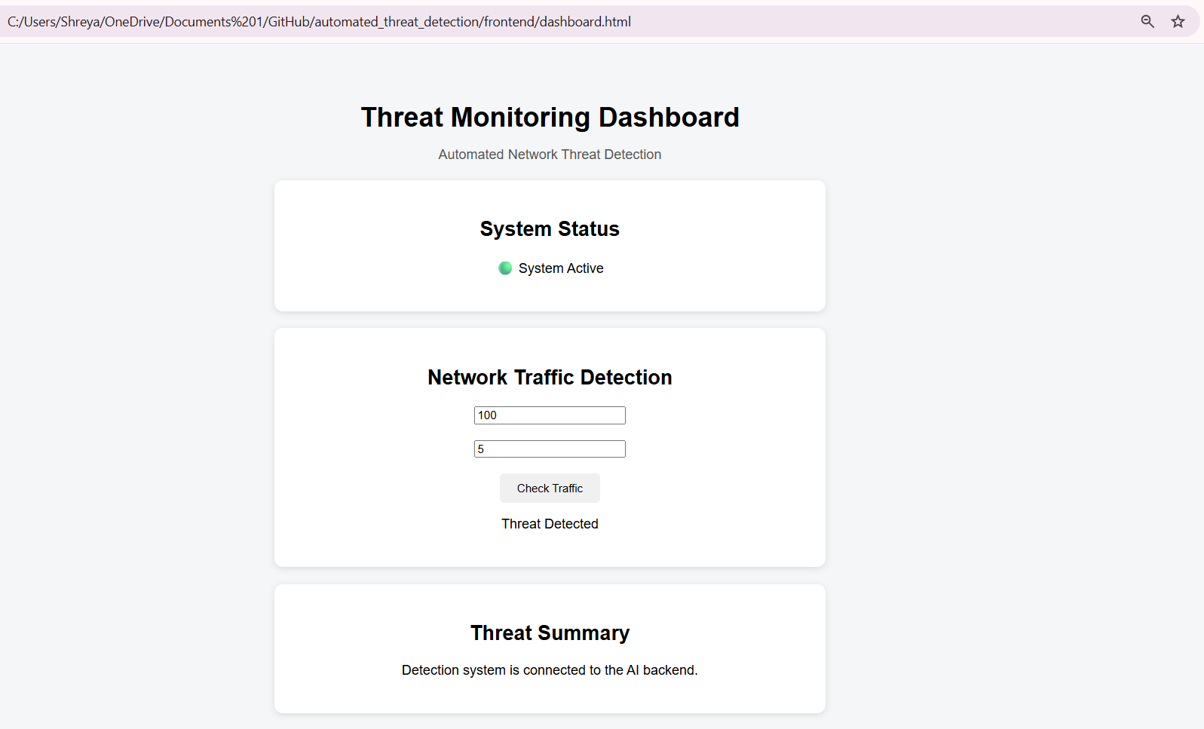
The actual result depends on the trained model and the input values.
12.1 Discussion
The project demonstrates how Machine Learning can be integrated into a practical web application.
However, the current results should be considered a demonstration of system functionality rather than proof of production-level threat detection performance.
The use of a small/synthetic dataset means that additional evaluation using larger real-world datasets would be necessary.

13. LESSONS LEARNED
During the development of the project, several technical and practical concepts were learned.
Machine Learning
The project provided an understanding of the basic Machine Learning workflow:
Dataset → Preprocessing → Training → Prediction
Model Integration
The project demonstrated how a trained Machine Learning model can be saved and loaded into another application.
Flask and API Development
The project provided practical experience in using Flask to create a backend and prediction API.
Frontend and Backend Communication
The dashboard and Flask API demonstrated how frontend and backend components communicate with each other.
Database Integration
SQLite provided practical experience in storing application and detection records.
Input Validation
The project showed why user input needs to be checked before processing.
Security Testing
Testing invalid and unexpected inputs helped demonstrate the importance of application security.
GitHub
GitHub provided experience in managing and maintaining project source code.
Cloud Deployment
Deploying the Flask application provided practical experience with production environments and API testing.
Importance of Data Quality
One of the major lessons learned was that the quality, size, and realism of the training dataset strongly affect the usefulness of a Machine Learning system.

14. RECOMMENDATIONS AND FUTURE SCOPE
The current system can be improved in several ways.
14.1 Larger Real-World Dataset
A larger and more diverse network traffic dataset can be used to improve model training and evaluation.
14.2 Additional Network Features
More features can be added, such as:
- Protocol information
- Source and destination information
- Connection duration
- Traffic frequency
- Other relevant network statistics
This can provide the model with more information for classification.
14.3 Improved Model Evaluation
Future versions can use proper evaluation techniques and metrics such as:
- Accuracy
- Precision
- Recall
- F1-score
- Confusion Matrix
Different models can also be compared to understand their performance on the same dataset.
14.4 Stronger Authentication
User authentication and authorization can be added to protect the dashboard and API.
14.5 Persistent Cloud Database
A managed cloud database can replace or supplement SQLite for production environments where persistent storage is required.
14.6 Improved Dashboard
The dashboard can be enhanced with:
- Graphs
- Threat statistics
- Historical detection records
- Traffic trends
- Detection summaries
- Alerts
14.7 Detailed Threat Classification
Instead of only:
Normal / Threat
future versions could identify different categories of network attacks.
14.8 Advanced Threat Detection
Future versions can explore:
- Anomaly detection
- Deep Learning
- Ensemble techniques
- Continuous monitoring
- More advanced intrusion detection approaches
14.9 Improved Feedback Loop
A reviewed feedback system can be developed where confirmed detection results are added to the training dataset and used for future model improvement.

15. CONCLUSION
The Automated Threat Detection System demonstrates how Machine Learning can be integrated with a web-based application to automate basic network traffic classification.
The project combines several important technologies and concepts, including:
- Python
- Pandas
- Scikit-learn
- Random Forest
- Flask
- SQLite
- HTML/CSS/JavaScript
- GitHub
- Render
The system accepts network traffic information such as bytes and packets, processes the input, and uses a trained Random Forest model to classify the activity as Normal Activity or Threat Detected.
The project also includes a dashboard, API, database logging, input validation, security testing, and cloud deployment.
Overall, the project provides a practical foundation for understanding how Machine Learning can be integrated into a security-oriented software application.
The current prototype has limitations because it uses a small/synthetic dataset and a limited number of features. Therefore, future development should focus on larger real-world datasets, stronger evaluation, additional network features, improved security, persistent storage, and more advanced threat detection methods.

16. REFERENCES
- Python Documentation — Python programming language documentation.
- Pandas Documentation — Data analysis and manipulation library for Python.
- Scikit-learn Documentation — Machine Learning library and algorithm documentation.
- Flask Documentation — Python web framework documentation.
- SQLite Documentation — Lightweight relational database documentation.
- GitHub Documentation — Repository and version-control documentation.
- Render Documentation — Cloud deployment and hosting documentation.

APPENDIX A — SYSTEM DEMONSTRATION FLOW
The following steps can be used during the project demonstration:
- Open the web dashboard.
- Enter the value for Bytes.
- Enter the value for Packets.
- Click the Check Traffic or detection button.
- The dashboard sends the request to the Flask API.
- The API validates the input.
- The validated data is sent to the Random Forest model.
- The model generates a prediction.
- The prediction is returned to the dashboard.
- The result is displayed as Normal Activity or Threat Detected.
- The detection information can be stored in SQLite.

APPENDIX B — SUGGESTED PROJECT SCREENSHOTS
The following screenshots can be added to the final report if available:
Screenshot 1 — Dashboard
Add your actual dashboard screenshot showing:
- Bytes input
- Packets input
- Detection button
- Detection result
Screenshot 2 — GitHub Repository
Show the project files stored in the GitHub repository.
Screenshot 3 — Render Deployment
Show the deployed Flask application or Render service.
Screenshot 4 — API Testing
Show a successful API request and response.

PROJECT WORKFLOW SUMMARY
AUTOMATED THREAT DETECTION SYSTEM

Network Traffic
↓
Data Preprocessing
↓
Random Forest Classifier
↓
Threat Classification
↙ ↘
Normal Activity Threat Detected
↓
Alert
↓
Threat Logging
↓
Feedback Loop
End of Report

